(a)Only detection without classification

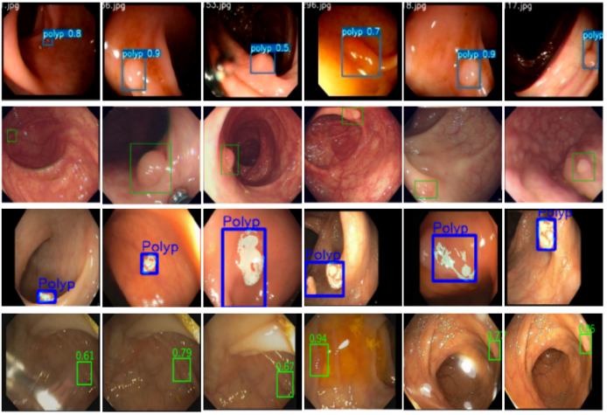

(b) detection

Bicategory

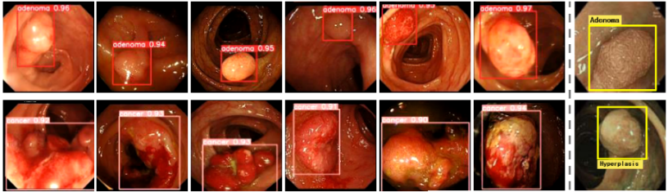

(c)Challenges in weakly supervised polyp detection

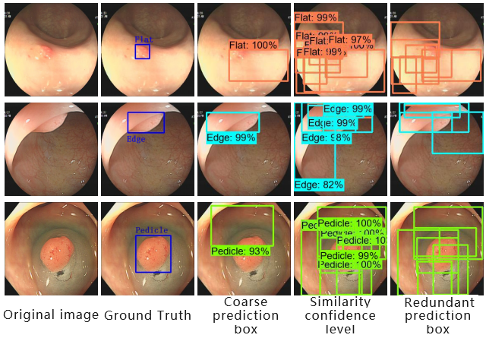

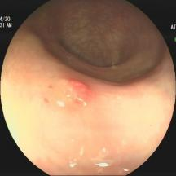 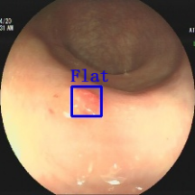 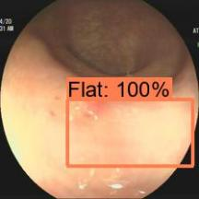 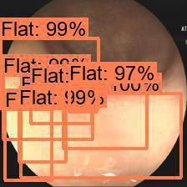 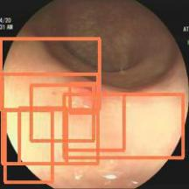

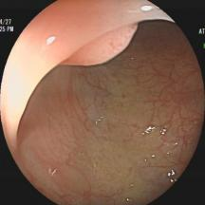 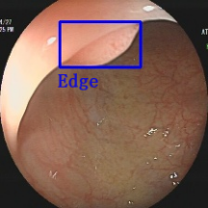 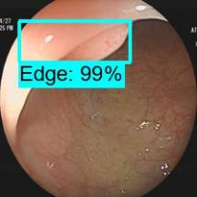 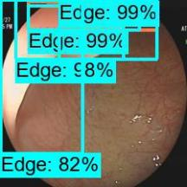 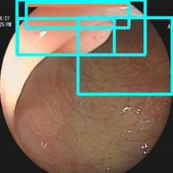

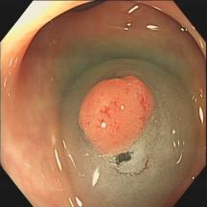 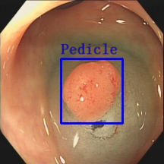 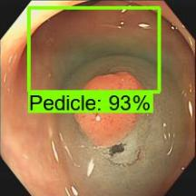 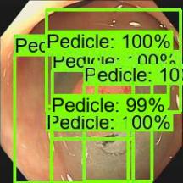 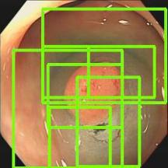

Original image Ground Truth Coarse prediction box Similarity confidence level Redundant prediction box

**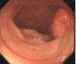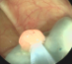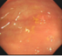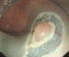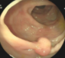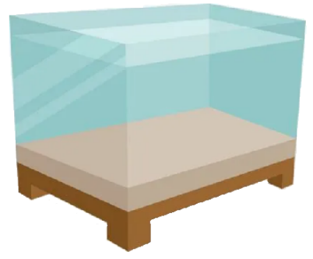**

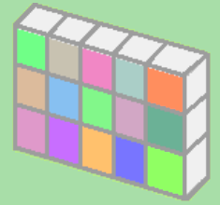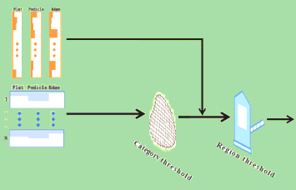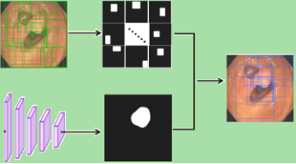

**Solution3**

**c) Our contribution and results**

**Challenges**

**Solution2**

**Solution1**



**Challenge 3**

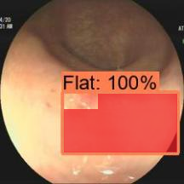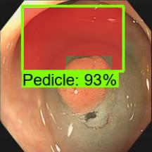

**Unexpected background areas**

**Undistinguish-ed confifence level**

**High false positive prediction**

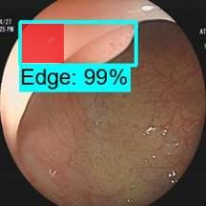

**Challenge 1**

**Challenge 2**

**Our**

**results**

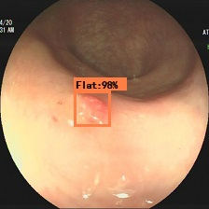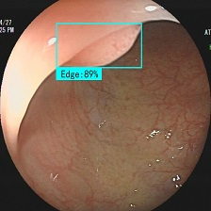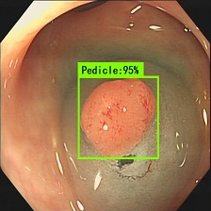

**Space category module**

**Contribution 2**

**Cross-reference module**

**Contribution 1**

**Contribution 3**

**Dual-threshold Postprocessing Strategy**

**Excepted prediction results**

1. **Challenges in weakly supervised polyp detection**
2. **Previous works with presence or bi-category detection**

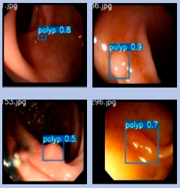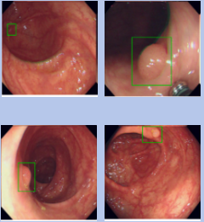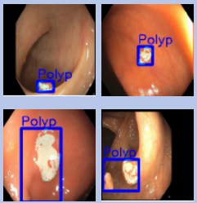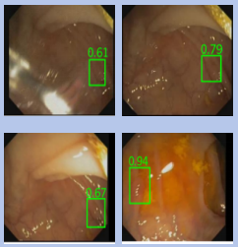

**Poon CCY et al. [21]**

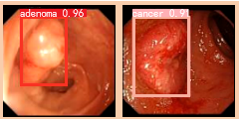

**[Junbo Gao](https://pubmed.ncbi.nlm.nih.gov/?term=Gao+J&cauthor_id=35103073) et al.[21]**

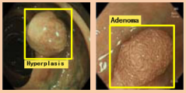

**[Juana González-Bueno](https://pubmed.ncbi.nlm.nih.gov/?term=Gonz%C3%A1lez-Bueno+Puyal+J&cauthor_id=36209637)**

**[Puyal](https://pubmed.ncbi.nlm.nih.gov/?term=Gonz%C3%A1lez-Bueno+Puyal+J&cauthor_id=36209637) et al.[21]**

**Ishak Pacal et al.[21]**

**[A Mohammed](https://xueshu.baidu.com/s?wd=author:(A Mohammed) &tn=SE_baiduxueshu_c1gjeupa&ie=utf-8&sc_f_para=sc_hilight=person" \t "https://xueshu.baidu.com/usercenter/paper/_blank) et al.[21]**



**[Lingyun Wu](https://link.springer.com/chapter/10.1007/978-3-030-87240-3_29" \l "auth-Lingyun-Wu) et al.[21]**

**Bi-category**

**Presence**

